Bean Autowiring
ByName
ReportCreator.java
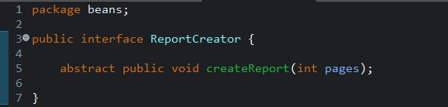
PdfReportCreator.java
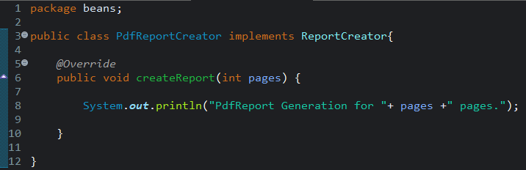
ExcelReportCreator.java
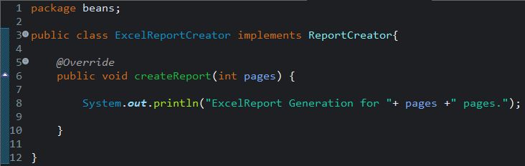

Reportmanager.java
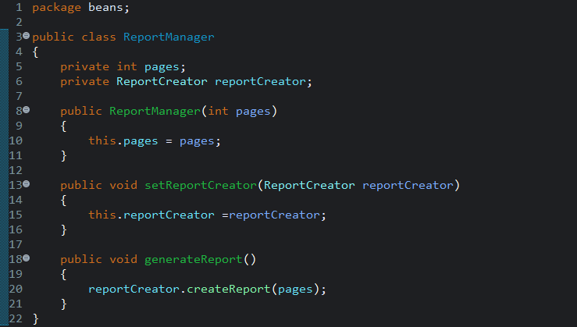
App.java
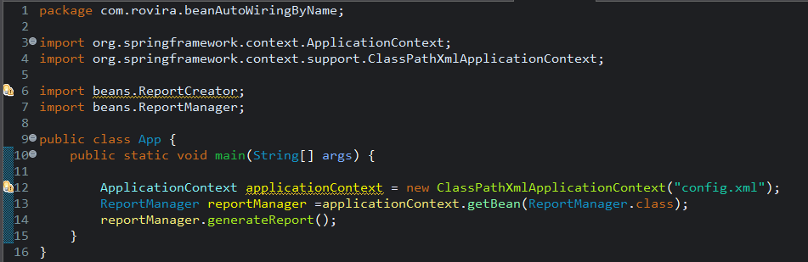
config.xml
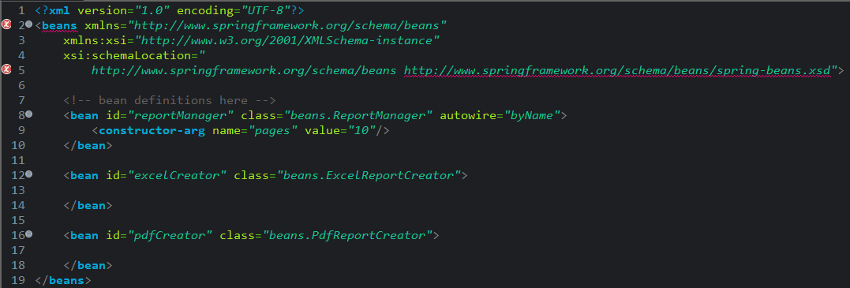

Output
Problem:
- ReportManager has setter setReportCreator(ReportCreator) → for byName autowiring, Spring looks for a bean with id="reportCreator" (derived from the setter name).
- In config.xml, the bean id for the implementation class didn't match reportCreator (it was named differently).
- byName/byType autowiring fails silently — no matching bean means Spring just skips injection, no error at startup.
- So reportCreator field stayed null, and calling reportCreator.createReport() in generateReport() threw NullPointerException.
Solution:
- Renamed the bean id in config.xml to exactly reportCreator, matching the setter-derived property name.
- Now Spring finds the matching bean by name and injects it correctly.
- reportCreator is no longer null → generateReport() runs fine and prints the expected output.

Solution:
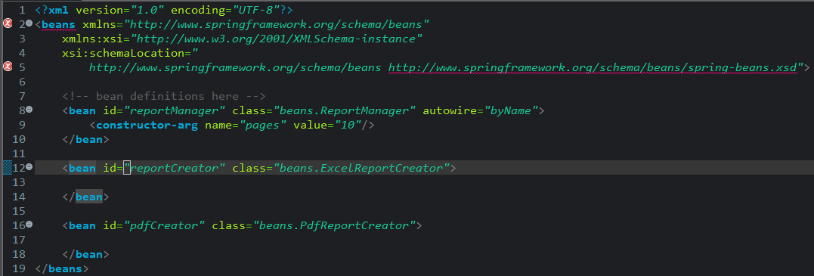
output:
